**Exercise 3a: Create a prototype with familiar and unfamiliar navigation elements. Evaluate ease of use with different user groups using proto.io**

**Aim:**

The aim is to develop a prototype incorporating both familiar and novel navigation elements and assess usability among diverse user groups using Proto.io.

**Procedure:**

**Step 1: Sign Up and Log In**

* Go to proto.io, sign up or log in.

**Step 2: Create a New Project**

* Click "Create New Project," name it, select device type (e.g., iPhone X), and click "Create."

**Step 3: Design the Home Screen**

* Add a new screen (Blank, name it "Home").
* Drag a "Header" widget, edit text to "Home Screen."
* Add a "Button" widget, change text to "Go to Profile."
* Set button interaction: Trigger = "Tap/Click," Action = "Navigate to Screen" → create "Profile" screen.

**Step 4: Design the Profile Screen**

* Add a "Header" widget, edit text to "Profile Screen."
* Add an "Image" widget for the profile picture.
* Add a "Text" widget for profile info (e.g., "John Doe, Software Engineer").
* Add a "Button" (Back to Home), set interaction: Trigger = "Tap/Click," Action = "Navigate to Screen" → Home.

**Step 5: Preview the Prototype**

* Click "Preview" and interact with the prototype.

**Step 6: Share the Prototype**

* Click "Share," copy the link, and send it for feedback.

**Output:**

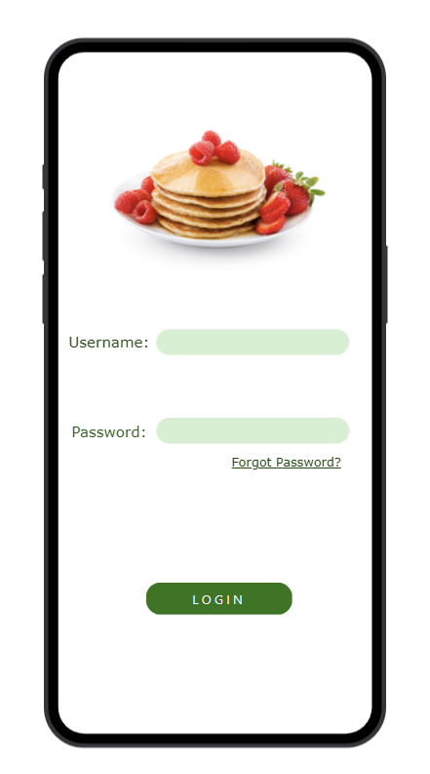 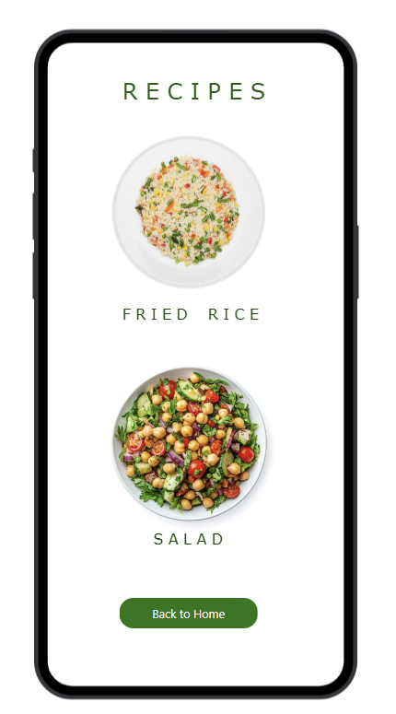

**Link:**

<https://pr.to/NBZTTR/>

**Result:**

Hence, the prototypes were successfully designed using Proto.io.